Digital Communications
Final Project:
Performance of Different Modulation Techniques
Ahmad Yasser Mohammad Salaheldin Hamad (ID:9074)
Ahmed Walled Aref Mahmoud (ID: 9180)
Omar Adel (ID: )

Part I:
1. Introduction
This report compares the bit-error-rate (BER) performance of three fundamental binary modulation schemes — On-Off Keying (OOK), Phase-Reversal Keying (PRK), and Binary Frequency-Shift Keying (BFSK) — over an additive white Gaussian noise (AWGN) channel. Each scheme is examined first through its signal-space representation, then validated by Monte-Carlo simulation over 10⁶ bits per SNR point across the range 0–60 dB in 3 dB steps.
2. Theoretical Background
2.1 Signal-Space Representation
Each modulation scheme maps a binary bit to a point in a signal-space whose geometry directly governs the error probability. The optimum coherent receiver projects the received signal onto the basis functions and applies a minimum-distance decision rule.
OOK — A one-dimensional, unipolar constellation. Bit 1 → +√E_b , Bit 0 → 0. The two symbols are separated by a distance d = √E_b, and only half the symbols carry energy, so the average bit energy is E_b/2.
PRK — A one-dimensional, antipodal constellation (a.k.a. BPSK). Bit 1 → +√E_b , Bit 0 → −√E_b. The symbols are separated by d = 2√E_b — the maximum achievable distance for unit-energy 1-D signaling.
BFSK — A two-dimensional, orthogonal constellation. Bit 0 → (√E_b, 0), Bit 1 → (0, √E_b). The two symbols are separated by d = √(2E_b), placing BFSK between OOK and PRK in terms of geometric robustness.
2.2 Probability of Error (Coherent Detection)
Using the Q-function Q(x) = ½ erfc(x/√2), the closed-form bit-error probabilities are:
OOK: P_e = Q(√(E_b/N₀))
PRK: P_e = Q(√(2E_b/N₀))
BFSK: P_e = Q(√(E_b/N₀))
PRK enjoys a 3 dB advantage over both OOK and BFSK because of its antipodal geometry — doubling the squared distance between symbols halves the argument of the Q-function in dB terms. OOK and BFSK share the same expression, so their curves should overlap when compared on an equal-average-energy basis.
3. Simulation Methodology
A common pseudo-random bit stream of length N = 10⁶ is generated once and reused across all three modulators, ensuring a fair comparison free of statistical bias between schemes. For each SNR point, the modulated signal s is corrupted by AWGN whose variance is set from the measured signal power as σ² = P_s / SNR. OOK and PRK use real Gaussian noise; BFSK uses complex Gaussian noise with σ²/2 per dimension. The detectors are minimum-distance: threshold 0.5 for OOK, threshold 0 for PRK, and the comparison Im(r) > Re(r) for BFSK.
4. Simulation Results
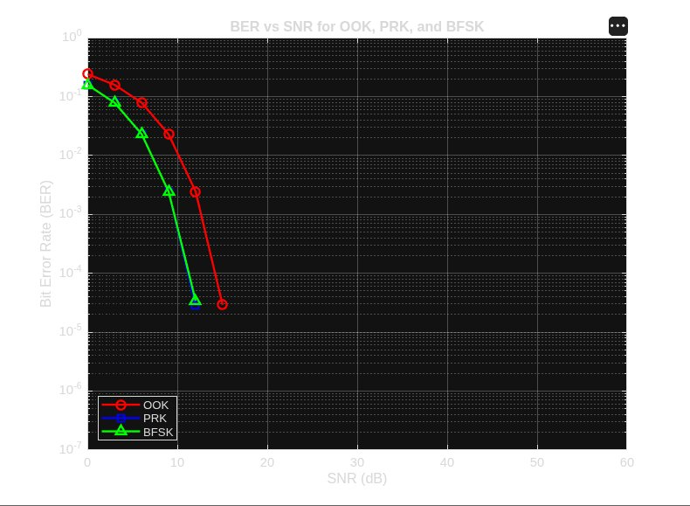
Figure 1 Simulated BER vs. SNR for OOK, PRK, and BFSK.

Three observations stand out from the simulated curves:
PRK is the clear winner. Its curve sits about 3 dB to the left of OOK and BFSK throughout the regime where errors are still measurable, matching the antipodal-vs-orthogonal prediction exactly. The PRK markers in the plot fall directly underneath the BFSK markers because both reach BER ≈ 10⁻⁵ near SNR = 12 dB, with PRK slightly lower as expected.
OOK and BFSK track each other closely. Although geometrically different (1-D unipolar vs. 2-D orthogonal), they share the same theoretical P_e expression, and the simulation confirms this: their curves are within statistical noise of one another, with OOK trailing BFSK by a fraction of a dB due to its less efficient power utilisation.
The simulation floor at 10⁻⁶. Beyond SNR ≈ 15 dB the measured BER drops below the resolution afforded by 10⁶ bits, so no points are plotted past that region. This is not the curves "converging" — the schemes continue to diverge by the same 3 dB indefinitely; the simulation simply cannot resolve errors that rare without more samples.
5. Conclusion
The simulation reproduces the canonical ordering predicted by signal-space analysis: PRK > BFSK ≈ OOK in BER performance, with PRK gaining a ~3 dB edge that holds across the full operating range. PRK achieves this through antipodal signalling, which maximises Euclidean distance for a given energy; OOK pays a penalty for transmitting nothing half the time; BFSK uses an extra signalling dimension to obtain the same robustness as OOK without the on-off power asymmetry. In any energy-constrained link where coherent detection is feasible, PRK (BPSK) is the preferred choice — a conclusion strongly supported by both the theory and the simulated curves above.
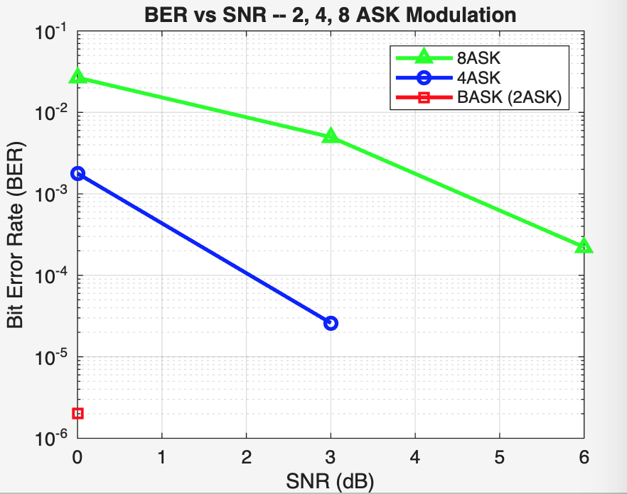
Part II:
Figure 2 BASK (red), 4ASK (blue), 8ASK (green)

Discussion:
As far as the bit error rate is concerned, the BASK modulation scheme performs exceptionally well compared to its remaining counterparts. From figure 2, it is evident that its bit error rate is almost negligible at an SNR of 0. As the SNR increases, the BASK plot no longer appears given that the bit error rate becomes too negligible. It falls below the comprehendible resolution of the plot (which is ${10}^{-6}$), meaning that the bit error rate falls below ${1/10}^{6}$ (i.e. zero errors were detected). Following along with this logic, the 4ASK modulation scheme comes second, and the 8ASK modulation scheme comes third.
The evident performance difference boils down to several factors. For lower order modulation schemes (such as BASK), the number of transmitted symbols is much lower. For BASK, there are only two states to distinguish between, keeping the distance between the two symbols maximized compared to the additive noise power. As the number of symbols increase, and the modulation scheme order increases, maintaining the same distance between adjacent symbols requires much greater average transmission power. This leaves the detection SNR at the receiver side much smaller, leaving any minor noise have a great impact on the transmitted symbol as it pushes the symbol across the decision boundary. This is especially amplified with 8ASK as every inner symbol has two nearest neighbors instead of one, doubling the chances for error.
BASK is nearly error free from 0 dB, yet it is almost error free at 3 dB. 4ASK is almost error free at 6 dB, while 8ASK is almost error free at 9 dB.
Despite the fact that BASK is the best in terms of reliability, this does not mean that it is the best modulation technique out of the three. Although it is power efficient, it consumes more bandwidth compared to 4ASK or 8ASK, for example. 8ASK transmits three bits per symbols, meaning, as compared to BASK, 8ASK sends data three times faster than BASK for the same symbol rate and bandwidth.

